the following screenshots are from the database which is included in zip file:

tf.db 🡪 forward indexing database

reverse.db 🡪 reverse indexing data

output is just for 100 files which are added in database

**Forward Indexing:**

Database:

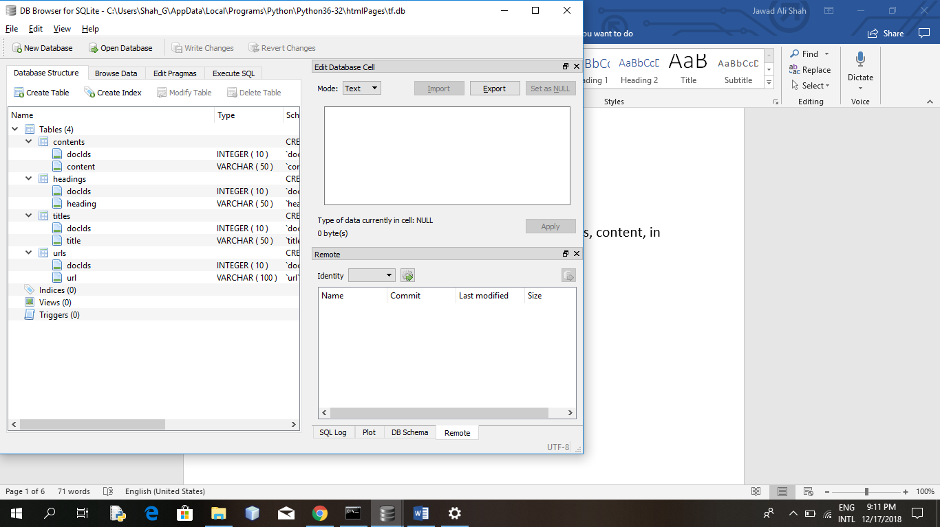

Check for the word “free” in each table of title, headings, content, in document 4

Titles: (free=0)

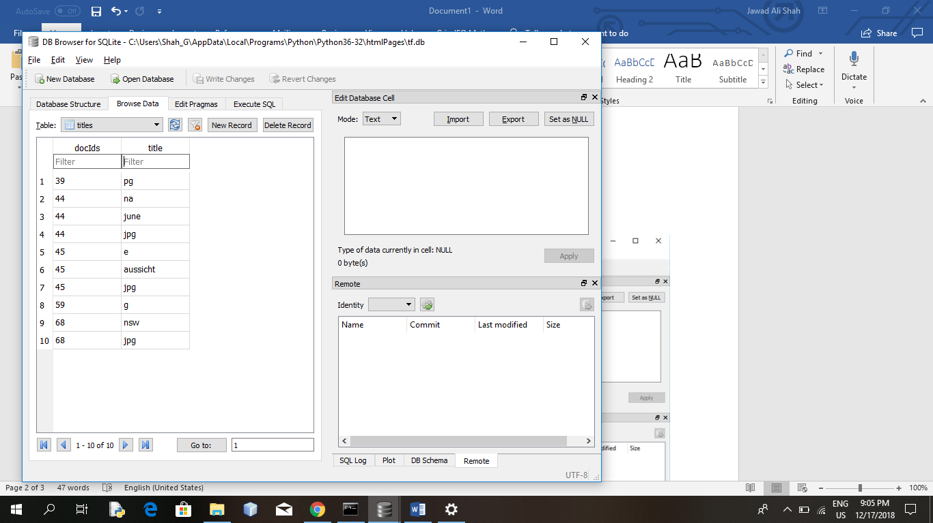

Headings: (free=2)

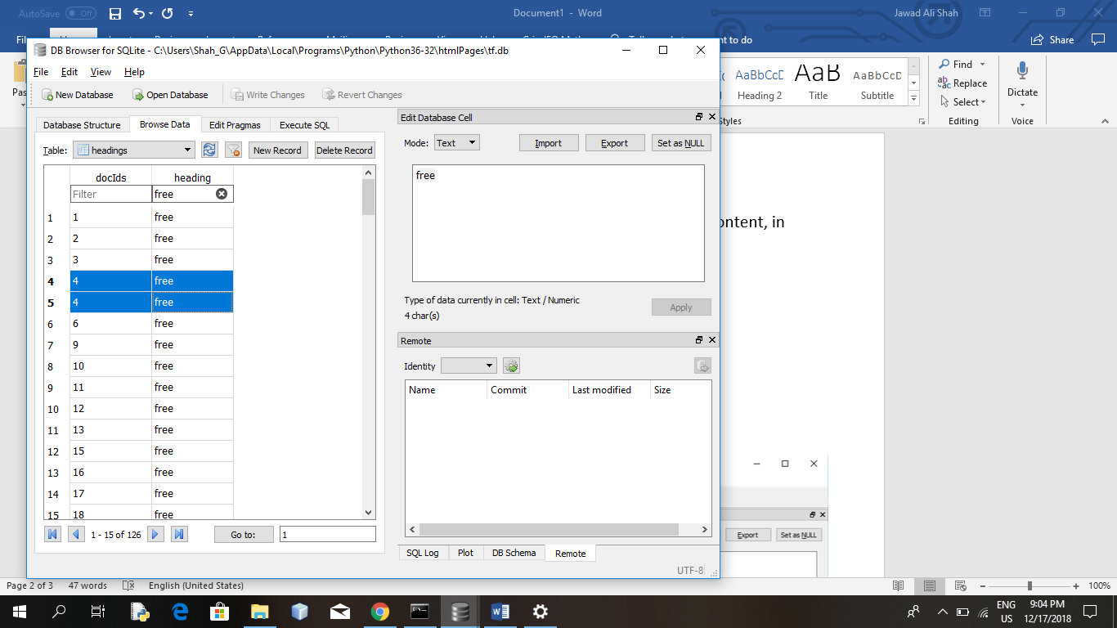

Contents: (free=4)

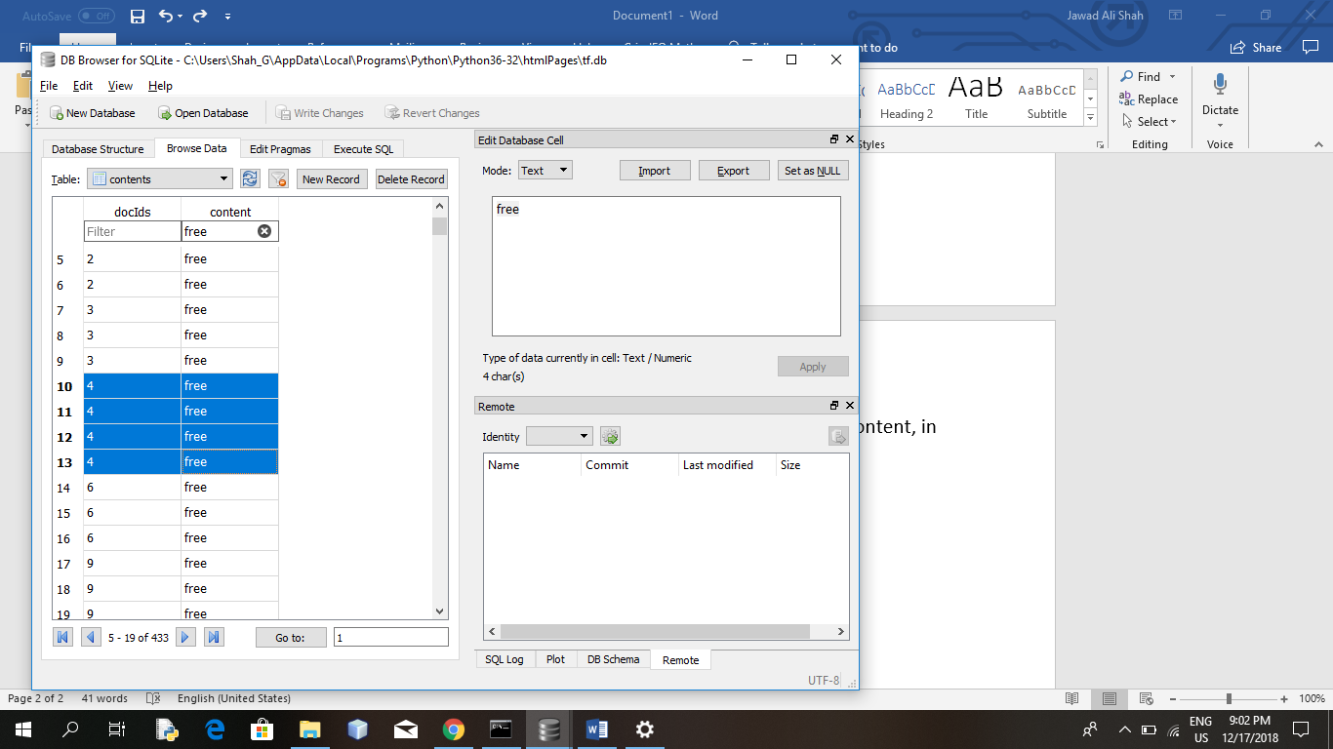

**Reversing Indexing:**

Database:

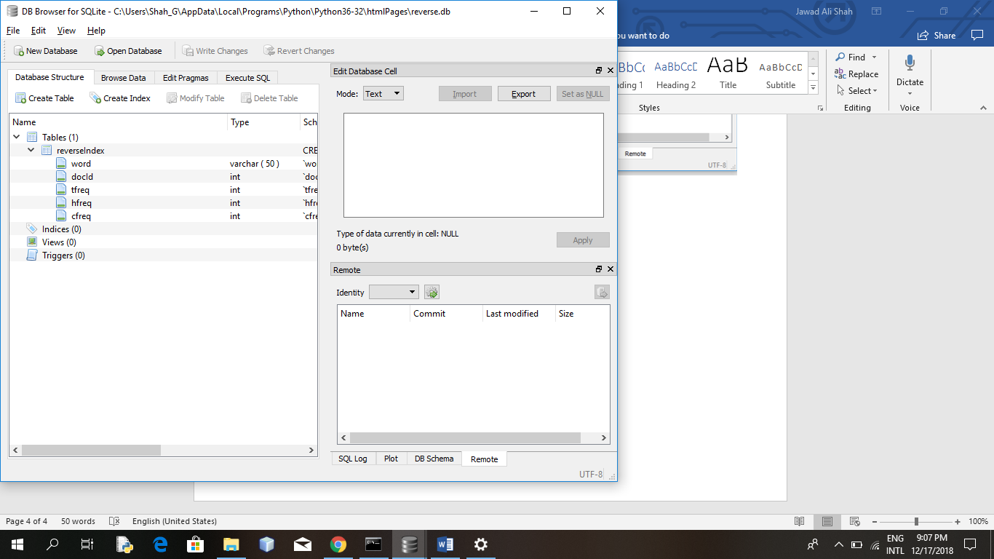

matching for word “free”:

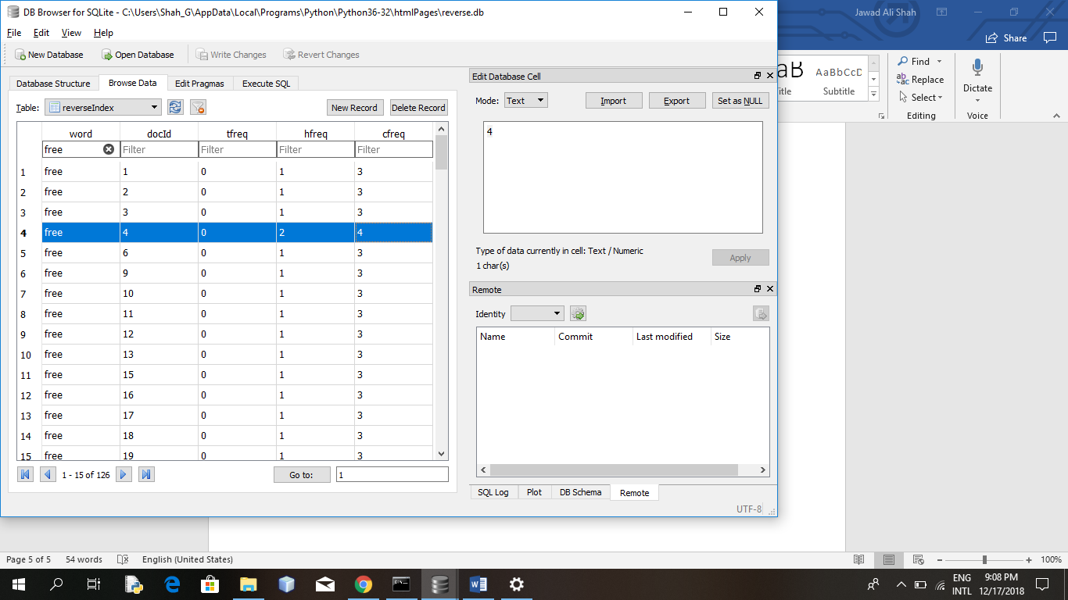

In doc=4: “free ” occurs 2 time in hfreq, 4 times in cfreq, 0 times in docId